Uniport Journal of
Engineering and Scientific Research (UJESR)
Vol. 6, Issue 2, 2022, Page 224-234
ISSN: 2616-1192
(www.ujesr.org)

© Faculty of Engineering, University of Port Harcourt, Nigeria.

Assessment of the Sedimentological and Geotechnical Characteristics of Soil Sediments in Selected Coastal Islands in the Niger Delta, Nigeria
Owonaro, B.J1, Okiotor, E.M*2, Chiokwe, V.N3 and Obi, S.C4
1,2,4Department of Marine Geology, Nigeria Maritime University Okerenkoko, Delta State
3Krisoral Group of Company, Habour Industrial Layout Onitsha Anambra State.
*Corresponding author’s email: michaelokiotor@gmail.com

Abstract
Sedimentological and geotechnical characteristics of soils in selected coastal communities of the Niger Delta have been studied. Eight soil samples in total were examined to ascertain their sedimentological and geotechnical characteristics using sieve analysis and Casagrande methods. Using statistical metrics, it was discovered that the sediments of Okerenkoko are mostly well-sorted fine sands that are almost symmetrical and leptokurtic, with values averaging 2.06, 0.59, -0.093, and 1.09 for grain sizes, sorting, skewness, and kurtosis. Cumulative frequency curves plotted, showed that these sediments deposited in low energy environments. Sediments from Kurutie community were predominantly moderately sorted medium sands that are strongly fine skewed and very platykurtic with values averaging 1.35, 0.967, 1.45 and 0.051 for grain sizes, sorting, skewness and kurtosis. Sediments from Kurutie were determined to have been deposited in high energy conditions. The bivariate plot showed that sediments from Okerenkoko were deposited by beach influenced depositional processes while sediments from Kurutie were fluvial influenced. Atterberg limit results showed that soil sediments collected from Okerenkoko had liquid limit values ranging between 13%-17% while that of Kurutie was between 10%-20%. No plastic limit values were recorded, hence the plastic indices values corresponded with liquid limit values. The results show that the soil sediment in these islands may have been deposited under medium to high energy environment and the environment ranged from fluvial to beach marine environments which is characteristics of the Niger Delta. Assessment of the geotechnical properties of the soil indicate that they can support engineering constructions.
Keywords: Sediments, Geotechnics, Sieve analysis, Marine, Environment

Received: 1st July, 2022 Accepted: 13th September, 2022

Introduction
Sediments deposited at coastal areas are composed of particles of solid materials that are moved or transported by water motion caused by waves or currents (Van, 1998). Sediments develop by weathering of pre-existing rocks, shell or fragments of organisms, organic materials or chemical precipitation. They may be deposited along the coast by river flow, wave action or current (Eliot, 2016). Sediments deposited forming soils after accumulation generally contain hints about their source, mode of transportation, medium of transportation and environment of deposition and are all linked by Sedimentary processes. Okiotor and Asuen (2019), using geochemical signatures and geostatistics demonstrated that sediments migrated from the Abakaliki anticlinorium to the Anambra basin following the
Santonian tectonic activities. Uzoegbu and Ikwuagwu (2016) did a Sedimentological characterization of the Ajali sandstone at Okigwe in the Anambra Basin to determine the textural properties of the sediments deposited. Observations based on grain size analysis showed a unimodal frequency distribution indicating a single origin for the sandstones. Statistics studies on the sediments showed a graphic mean range from 1.5 to 2.8, sorting range from 0.45 to 0.32 and kurtosis between 0.38 and 2. The sandstones were concluded to be moderately sorted, strongly coarsely skewed and platykurtic.
Gideon et al. (2014) carried out studies on the sedimentological characteristics and geo-chemistry of the Ajali sandstones exposed at Ofe-jiji Northern Anambra Basin, Nigeria to determine the origin of the sediments deposited and infer its textural

characteristics. Studies based on grain size analysis showed that the sandstone sediments were medium-coarse grained (averaging 1.13mm in diameter), poorly sorted and strongly coarse skewed with an average skewness value of -0.72. Mineralogical composition indicated that the sandstone exhibits average SiO2 content ranging from 59.12% to 60.20% with an average value of 59.80% while alumina (Al2O3) content range between 2.51% and 2.75% with an average of 2.63%. The mineralogical composition showed on average 56.98% quartz, 6.30% feldspar, 31.78% rock fragment with a major framework composition of Q36F6L36 thus describing the sandstones as lithic arenite. All studies suggested that the sediments were of fluvial origin.
In the coastal region of the Niger Delta, sediments are along the coast and are part of the Niger Delta distributary channels. The river Escravos serve as a medium for the influx and outflux of sediment along the coasts of the communities connecting creeks and other communities of the Gbaramatu Kingdom supplying water and sediment to the Atlantic Ocean. Therefore, this study examines the sediments characteristics with a view to determining their
depositional history, paleodepositional environment and geotechnical properties.

Materials and methods
  - Field sampling procedure
Samples were collected from a depth of 1 meter, employing systematic method of sampling from the East, West, North and South co-ordinates of the two communities. These samples were collected using hand auger, they were then bagged in appropriately labelled polythene bags to preserve the integrity of the sediments. Co-ordinates and ground elevations of the sampled points were gotten from a portable global positioning system (GPS) receiver (See Fig. 1).

Study area
The study area is located within longitude 5037`0`` N and latitude 5024`25``E for Okerenkoko and longitude 5037`09.`` N and Latitude 5024`24.`` E for Kurutie along the Escravos river channel and about 2 km from the Escravos terminal which is at the edge of the Atlantic Ocean.

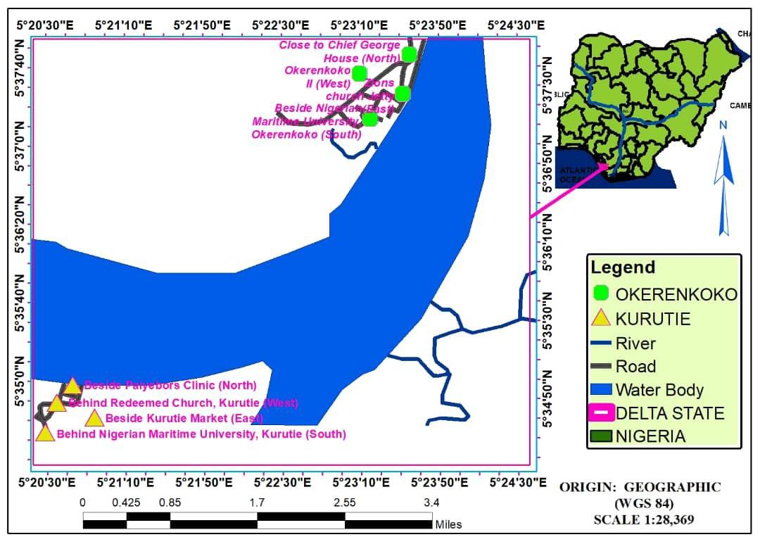

Fig 1: Sample points along the Escravos estuaries of the Niger Delta coastline

Table 1: Sample point coordinates

Points where samples were collected and their coordinates | Representation | Latitude | Longitude | Ground elevations (M)
Beside Nigeria Maritime University  (South) | OK1 (3ft) | 5 0 37’ 13’’N | 50 23’ 15”E | 31.1
Zion’s Church jetty (East) | OK2 (3ft) | 50 37’ 25’’N | 50 24’ 34’’E | 35.9
Close to Chief George’s house (North) | OK3 (3ft) | 50 37’ 41’’N | 50 23’ 35’’E | 33.7
Okerenkoko II (West) | OK4 (3ft) | 50 37’ 37’’N | 50 23’ 21’’E | 31
Beside Paiyeibor’s Clinic (North) | KT1 (3ft) | 50 34’ 58’’N | 50 20’ 43’’E | 26
Behind Kurutie market (East) | KT2 (3ft) | 50 34’ 50’’N | 50 20’ 50’’E | 31.4
Behind Redeemed church, Kurutie (West) | KT3 (3ft) | 50 34’ 49’’N | 50 20’ 35’’E | 29.9
Behind Nigeria Maritime University  Kurutie (South) | KT4 (3ft) | 50 34’ 38’’N | 5020’29.1’’E | 28.6

Grain-size analysis
A total of 8 samples were collected and analyzed to determine the spatial trend in their grain size distribution. 700grams of each sample collected was heated to remove the moisture content before grain size analysis. The dried samples were disaggregated, bagged in carefully labelled polythene bags before they were taken to the lab for sieve analysis. A pan was placed below the finest sieve to catch the last of any fine material that was not retained by the sieves. The arranged column of sieves was now transferred to a mechanical sieve shaker (Humboldt) for a period of 10-15minutes. When sieving was achieved, the fraction of the samples retained on each sieve was emptied at different turns on different sheets of paper and grains remaining on each sieve were removed with a fine sieve brush. These were then weighed and treated statistically

Liquid limit
Liquid limit is defined as the point at which a soil sample starts to flow like liquid. A total of eight sediment samples were taken to the lab to be analyzed. Samples were oven dried and allowed to cool and pass through a sieve of 0.425mm in the lab. The Casagrande equipmentwas inspected to ensure it is clean, dry and in working condition. The equipment was adjusted to zero while 120grams of each oven dried sample was weighed before addition of 10ml of distilled water in a glass plate to form a paste of each sample which was achieved with a spatula. Each sample was left for 24hours to ensure uniform mash distribution. A portion of paste formed for each sample for analysis was transferred to a brass cup of the
equipment, this was done at different turns for each sample collected from the field. The paste present in the cup of the Casagrande equipment was squeezed down and spread while ensuring that the maximum depth of the soil in the cup is 1cm. The grooving tool was used to groove the sample into two halves in a direction perpendicular to the axis of rotation of the handle. The handle rotated at the rate of two revolutions per seconds till to halves of the soil cake came in contact by flowing and not by sliding with the bottom of the groove with a distance of about 12mm. The crank was made to count the number of blows before the groove was covered. A part of the sample was collected from the equipment using a spatula into a metal can with known weight. It was ensured that the spatula cuts the soil cake at right angle to the grove. The moisture content was determined using a weighing balance and right after it was oven dried till the amount of water in the sample was evaporated.

Plastic limit
This can be described as the moisture content at which the soil samples behave as plastic, it is expressed as % of the weight of the oven dried soil which is the boundary between plastic and semi- solid state of consistence were the semisolid sample begins to break or crumble when rolled into a tread of 1/8in or 3mm. The test was carried out using the left over from the thoroughly mixed portion of the soil prepared for liquid limit (L.L) test. A moulded ball of each sample weighing about 8g was taken and rolled into a thread of 1/8in or 3mm at 80-90 strokes per minute on a glass plate so that a thread of uniform diameter is formed. This is done to note the point where there is a crack,

break or crumble. The crumbs are collected and oven dried and the moisture content determined.

Results and discussion
  - Grain size results analysis
From the grain size analysis results, histograms and cumulative frequency curves were plotted (Fig. 2-9). Thereafter, different quantitative values for various percentiles values such as the 5th, 16th, 84th, and 95th phi (Ø) values were determined from the cumulative curves and used for the calculation of the standard deviation (Table 2). Results of grain size analysis for samples from Okerenkoko community showed grain size with Ø values of 2.17Ø, 2.13Ø, 1.65Ø, 2.26Ø (Table 2) describing them as medium to fine sands and averaging 2.06 Ø, standard deviation values of 0.40Ø, 0.45Ø, 1.15Ø, 0.38Ø describing them as poorly to well sorted averaging 0.60Ø, skewness values are 0.087,
-0.044, -0.437, 0.021 describing them as near symmetrical averaging -0.093, and kurtosis values of 1.18, 0.95, 1.42, 0.82 describing them as platykurtic, leptokurtic and mesokurtic averaging
1.09 thus expressing them as predominantly well sorted fine sands that are near symmetrical and leptokurtic (Table 3) indicating a low energy conditions of deposition which travelled by
suspension away from it source (Bogs, 2006) Leptokurtic expressing the dominance of a particular grain size due to its high peakedness from the normal distribution curve (Selley, 2000).
Results of grain size analysis for samples from Kurutie showed grain size phi (Ø) values (1.3, 2.08, 0.7, 1.33 describing them as coarse, medium and fine sands averaging 1.35) , standard deviation values (-0.272, 0.96, 1.8, 1.38 describing them as poorly, moderately and very well sorted averaging 0.97), skewness values (1.17, 2.40, 0.72, 1.52 describing them as strongly fine skewed averaging 1.45) and kurtosis values ranging from (1.52, - 0.295, -0.545, -0.478 describing them as very leptokurtic to mesokurtic averaging 0.051) (Table
- as such the energy and conditions, and environment of deposition are slightly different from those of Okerenkoko as they are predominantly moderately sorted medium sands that are strongly fine skewed and very platykurtic which showed high energy conditions of deposition, having an uncertain transportation of the sediment which were determined to be by traction and saltation. Platykurtic indicating a saggier distribution curve from normal and strongly fine skewed with the lopsidedness either positive or negative (Selley, 2000).

Table 2: Calculated Percentiles from the cumulative frequency curve for Okerenkoko (OK) and Kurutie (KT)

Sample Representation | Ø 5 | Ø 16 | Ø 25 | Ø 50 | Ø 75 | Ø 84 | Ø95
OK1 | 1.4 | 1.8 | 1.95 | 2.1 | 2.4 | 2.6 | 2.7
OK2 | 1.2 | 1.7 | 1.75 | 2.1 | 2.4 | 2.6 | 2.7
OK3 | -1.6 | -0.1 | 0.6 | 1.4 | 1.8 | 2.0 | 2.55
OK4 | 1.6 | 1.9 | 2 | 2.25 | 2.6 | 2.7 | 2.8
KT1 | -1.7 | 0.25 | 0.75 | 1.4 | 1.95 | 2.25 | 2.75
KT2 | -1.3 | 1.5 | 1.75 | 2.1 | 2.5 | 2.65 | 3.1
KT3 | -2.4 | -1.5 | -0.7 | 1.6 | 2.3 | 2.5 | 2.9
KT4 | -1.9 | -0.2 | 1 | 1.7 | 2.25 | 2.5 | 2.75

Table 3: Calculated grain size parameters and description

Sample Representation | Mean Grain Size | Sorting | Skewness | Kurtosis | Sample Description
OK1 | 2.17 | 0.40 | 0.087 | 1.18 | Fine sand, well sorted, near symmetrical, leptokurtic
OK2 | 2.13 | 0.45 | -0.044 | 0.95 | Fine sand, well sorted, near symmetrical, mesokurtic
OK3 | 1.65 | 1.15 | -0.437 | 1.42 | Medium sand, poorly sorted, near symmetrical, leptokurtic
OK4 | 2.28 | 0.38 | 0.021 | 0.82 | Fine sand, well sorted, near symmetrical, platykurtic
Average | 2.06 | 0.595 | -0.093 | 1.09 | Fine sand, moderately well sorted, near symmetrical, leptokurtic
KT1 | 1.3 | -0.272 | 1.17 | 1.52 | Medium sand, very well sorted, strongly fine skewed, very leptokurtic
KT2 | 2.08 | 0.96 | 2.40 | -0.295 | Fine sand, moderately sorted, strongly fine skewed, very platykurtic
KT3 | 0.7 | 1.8 | 0.72 | -0.545 | Coarse sand, poorly sorted, strongly fine skewed, very platykurtic
KT4 | 1.33 | 1.38 | 1.52 | -0.478 | Medium sand, poorly sorted, strongly fine skewed, very platykurtic
Average | 1.35 | 0.97 | 1.45 | 0.051 | Medium sand, moderately sorted, strongly fine skewed, very platykurtic

Fig 2: Grain size cumulative curve for KT1
Grain size cummulative curve for KT1
120
100
80
60
40
20
0
-3
-2
-1
0
1
Phi Scale
2
3
4
5
Cumulative % Weight

Fig 3: Grain size cumulative curve for KT2
Grain size cummulative curve for KT2
120
100
80
60
40
20
0
-3
-2
-1
0
1
Phi size
2
3
4
5
Grain size cummulative curve for KT3
120
100
80
60
40
20
0
-3
-2
-1
0
1
Phi size
2
3
4
5
cumulative % Weight
Cumulative % Weight

Fig 4: Grain size cumulative curve for KT3
Grain size cummulative curve for KT4
120
100
80
60
40
20
0
-3
-2
-1
0
1
Phi size
2
3
4
5
Cumulative % weight

Fig 5: Grain size cumulative curve for KT4

Fig 6: Grain size cumulative curve for OK1
Grain size cummulative curve for OK1
120
100
80
60
40
20
0
-3
-2
-1
0
1
2
3
4
Phi size
Grain size cummulative curve for OK2
120
100
80
60
40
20
0
-20 -3
-2
-1
0
1
Phi size
2
3
4
5
Cumulative % Weight
Cumulative % Weight

Fig 7: Grain size cumulative curve for OK2
Grain size cummulative curve for OK3
120
100
80
60
40
20
0
-3
-2
-1
0
1
Phi Size
2
3
4
5
Cumulative % Weight

Fig 8: Grain size cumulative curve for OK3

Fig 9: Grain size cumulative curve for OK4
Histogram of grain sizes for OK4
120

100

80

60

40

20

0
-3
-2
-1
0
1
Phi size
2
3
4
5
Cumulative % Weight

Bivariate analysis
The bivariate plot of skewness against standard deviation (sorting) Fig. 10 and skewness against kurtosis Fig. 11 (Friedman, 1967) was plotted. These were used for differentiating between beach
and river sands (Fig. 10 & 11). The sediments of Okerenkoko were determined to be deposited in beach influenced depositional processes, while those of Kurutie were influenced by fluvial deposition processes.

Fig. 10: Bivariate diagram of skewness against sorting for Okerenkoko and Kurutie sediments
Biveriate plot of skewness against sorting for Okerenkoko and
Kurutie
1.5
Kurutie
1
Okerenkoko
0.5
0
Beach Sands
River Sands
-0.5
-1
-0.5
0
0.5
1
Sorting
1.5
2
2.5
3
Skweness

Fig. 11: Bivariate diagram of skewness against kurtosis for Okerenkoko and Kurutie sediments
Bivariate plot of skewness against kurtosis for Kurutie and
Okerenkoko
2

1.5
Okerenkoko
Kurutie
1

0.5
Beach Sands
0

-0.5

-1
-1
-0.5
0
0.5
River Sands
1 1.5
2
2.5
3
Kurtosis

Atterberg limit test
From the Atterberg limit results, it was observed that samples collected from Okerenkoko had liquid limit values of 13%, 17%, 13%, and 16% (Table 5). No plastic limit values were recorded for samples collected from Okerenkoko at 3ft depth indicating that they were non-plastic at such depth as samples could not be rolled into 3mm thread hence plastic index values corresponded with liquid limit values. At Kurutie, liquid limit values were recorded to be 10%, 20%, 16%, , and 18% (Table 5). A plot of the Atterberg’s limit parameters on the Casagrande (1984) plasticity charts (Figures 6) indicate that the
soil sediments are predominantly sandy materials devoid of clayey as they fall all points fall along the A-line. No plastic limit values were recorded for the samples collected at 1m depth indicating they were also non-plastic hence plastic index values corresponded with liquid limit values (Table
- in accordance with Ola (1981). This was probably due to absence of clay materials at such depth in both communities as samples could not be rolled into 3mm thread thus describing the sediments as predominantly composed of sands and silts.

Table 4: Atterberg limit test
Skewness

Location Depth (Ft) Atterberg Limit Test
 |  | LL (%) | PL (%) | PI (%)
OK1 | 3 | 13 | - | 13
OK2 | 3 | 17 | - | 17
OK3 | 3 | 13 | - | 13
OK4 | 3 | 16 | - | 16
KT1 | 3 | 10 | - | 10
KT2 | 3 | 20 | - | 20
KT3 | 3 | 16 | - | 16
KT4 | 3 | 18 | - | 18

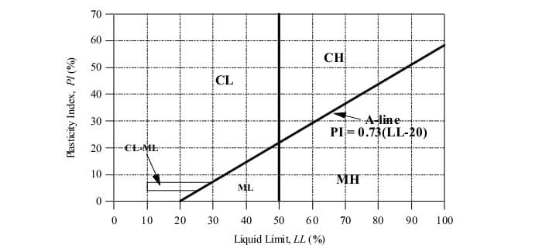

Fig. 12: Atterberg limit test data for soil samples recovered from the field

Conclusion
Results of grain size analysis for samples from Okerenkoko community showed that the sediments were predominantly well sorted fine sands that are near symmetrical and leptokurtic, and have travelled by suspension away from its source and deposited in low energy environment. Leptokurtic indicating dominance of a particular grain size due to its high peakedness from the normal distribution curve (Selley, 2000). Results of grain size analysis for samples from Kurutie showed that the sediments were predominantly moderately sorted medium sands that are strongly fine skewed and very platykurtic, having an uncertain transportation varying between traction and saltation and deposited in high energy environment. The bivariate plot of skewness against standard deviation and skewness against kurtosis revealed that the sediments were deposited in beach influenced depositional processes for Okerenkoko and fluvial influenced deposition processes for Kurutie. The Atterberg limit results, revealed that the sediments were non-plastic at such depth hence plastic index values corresponded with liquid limit values. At Kurutie, liquid limit values ranged between 10%-20%. and no plastic limit values were recorded for the samples collected indicating they were also non-plastic hence plasticity index values corresponded with liquid limit values. Since the soils have very low liquid limit and Plasticity index values corresponding with the liquid limit values, and no plastic limit values were found, they would be very good as subgrade materials and will
need very minimal compaction before being used

for engineering constructions. They soil in this area will also support engineering structures.

References
Bogs, S. (2006) Principles of Sedimentology and Stratigraphy. 4th Edition. Pearson, Education, Inc. p.49-158.
Casangrande, A. (1984) Classification and Identification of Soils. Trans ASCE Vol. 113, p.904.
Eliot, M. (2016) Coastal sediments, beaches and other soft shores. Coast Adapt Information Manuel 8, Natural Climate Change Adaptation Research, Facility Gold Coast. p.2-5.
Friedman, G.M. (1967) Dynamic processes and Statistical parameter compared for the size frequency distinction of beach and river sand. jour.Sed.Petrology (write name in full), 37:327- 354.
Gideon, Y.B., Fatoye, F.B. and Omada, J.I. (2014) Sedimentological Characteristics and Geo- Chemistry of Ajali Sandstone Exposed at Ofe- Jiji and Environs, Northern Anambra Basin, Nigeria. Research Journal of Environmental and Earth Sciences, 6(1):10-17.
Ola, S.A. (1981) Mineralogical properties of some Nigeria residual soils. Engineering Geology, 15:1-13.
Okiotor, M.E. and Asuen, G.O. (2019) Investigation of Sediment Migration from The Abakaliki Anticlinorium to the Anambra Basin. Society of Petroleum Engineers’(SPE) Journal, ‘One Petro’, SPE-198774-MS, p.3-18.

Selley, R.C. (2000) Applied Sedimentology. 2nd Edition. p. 48-53.
Uzoegbu, M.U. and Ikwuagwu, C.S. (2016) Sedimentological Charateristics of Ajali Sandstone at Okigwe, Anambra basin, South-
East Nigeria. International Journal Geology and Mining, 2:038-052.
Van Rijin, L.C. (1998) Principles of coastal morphology, Aqua Publications. p.730.

